**Update metadata in Dynamo Db when any file is updated in S3 bucket**

1. **Create IAM role**

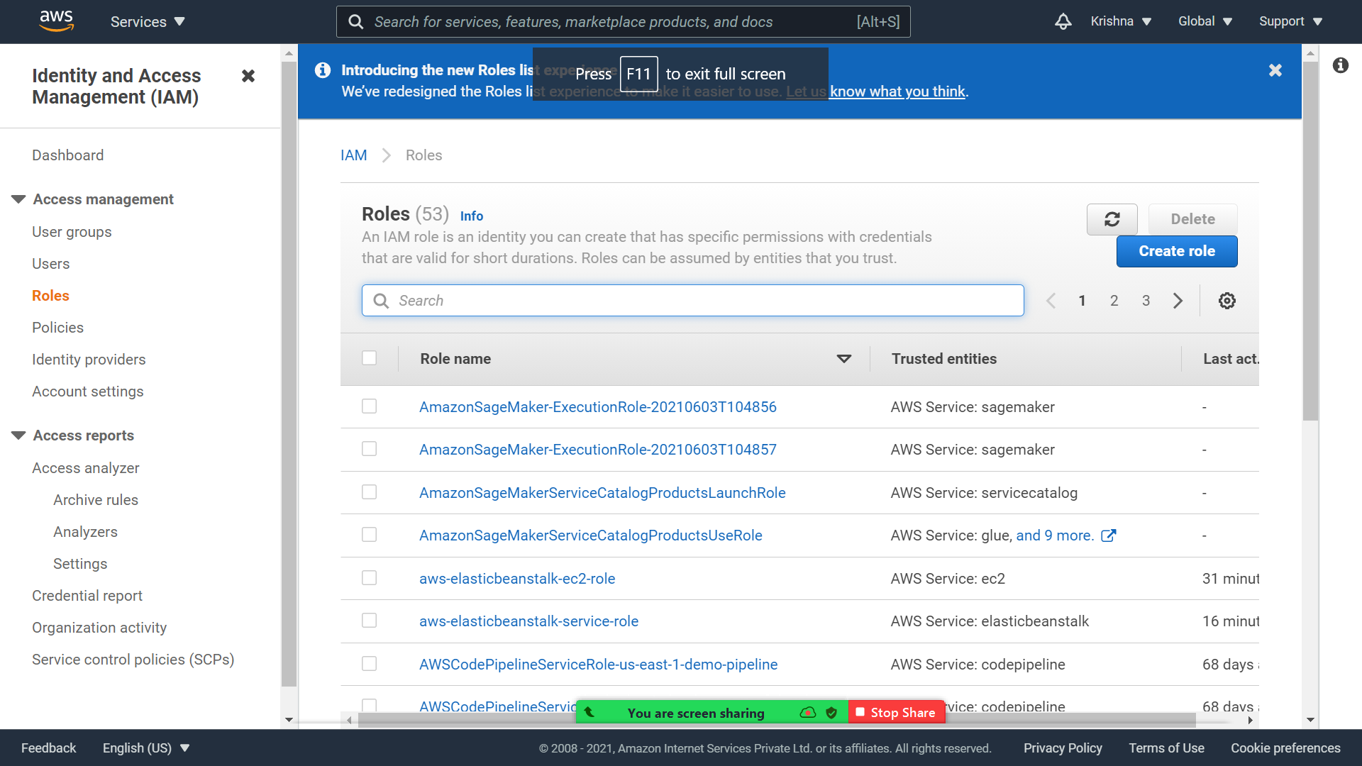

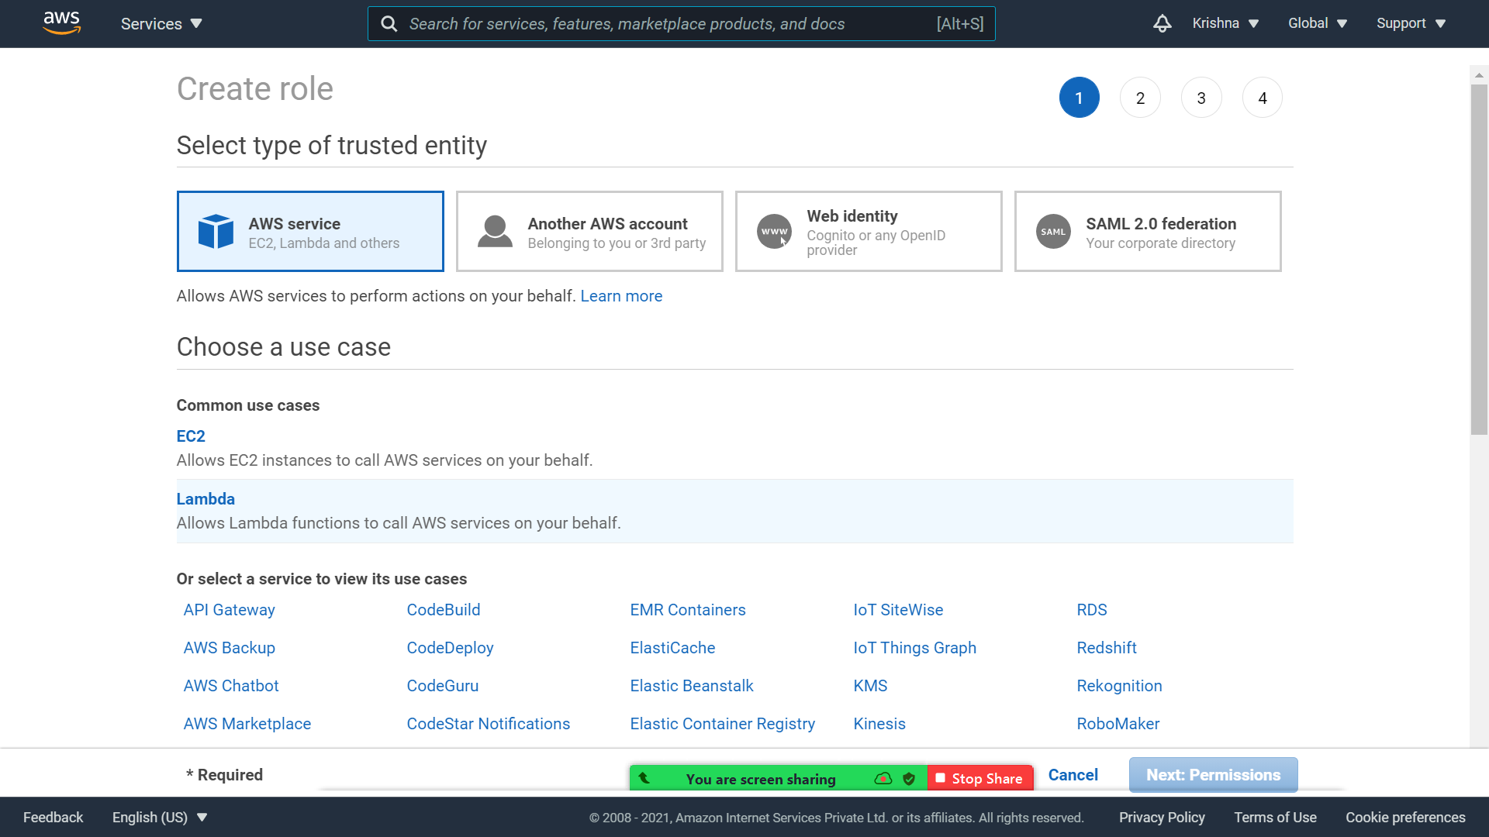



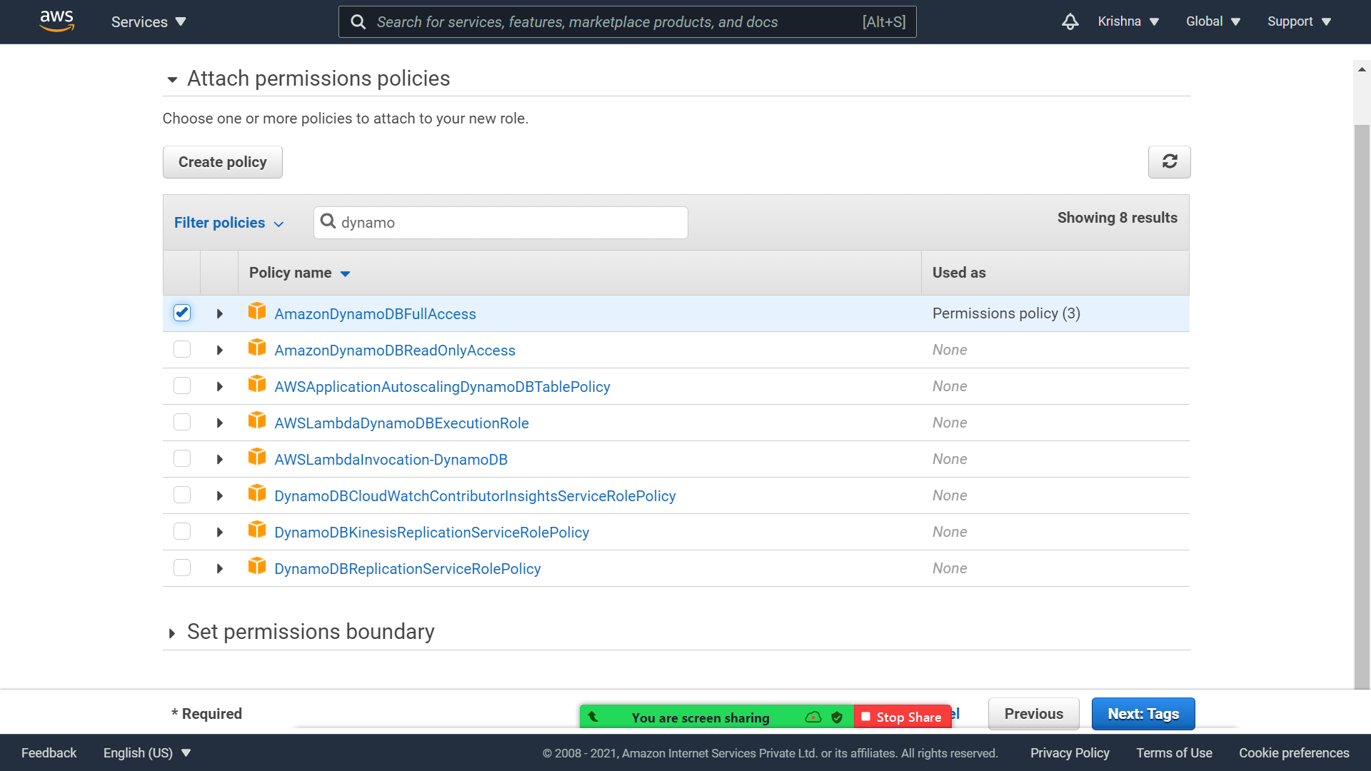



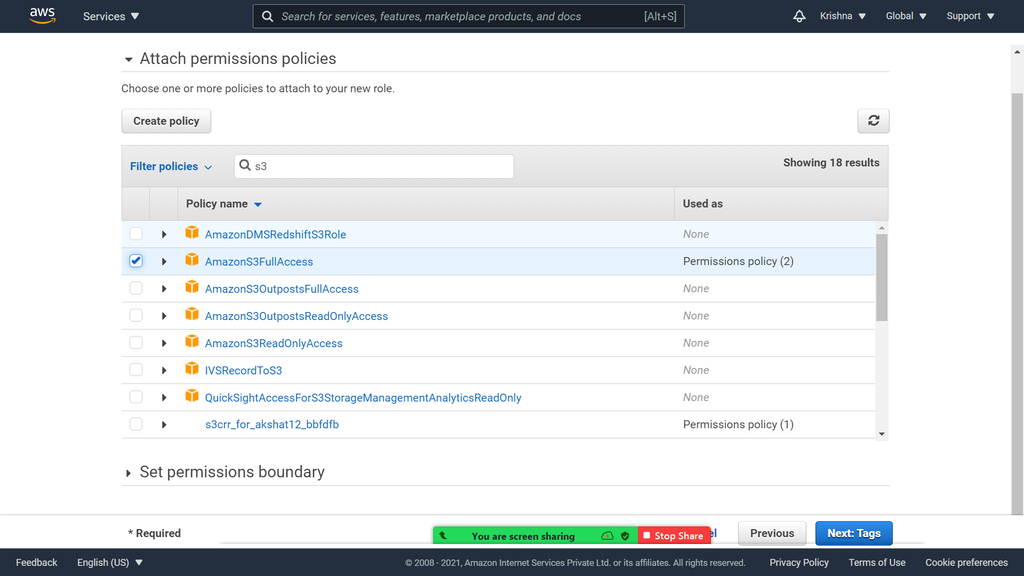



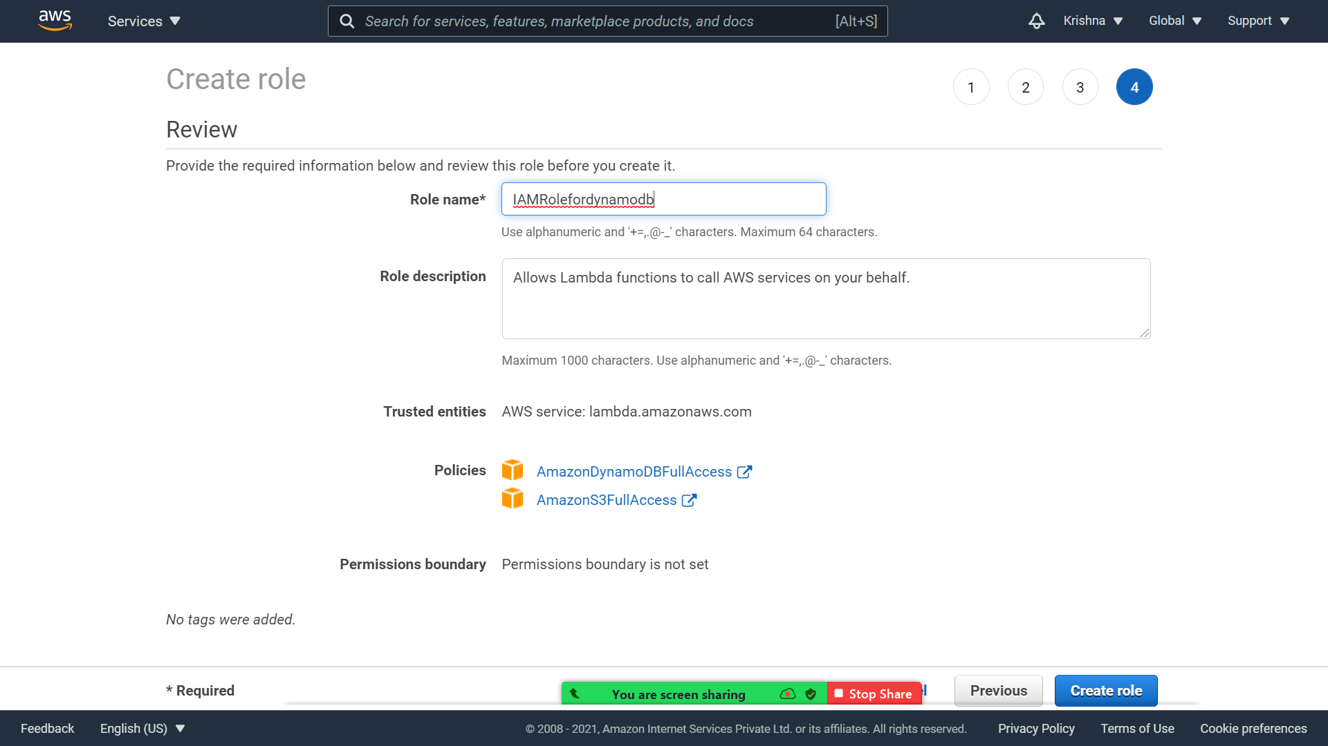

1. **Create s3 bucket and give public access.**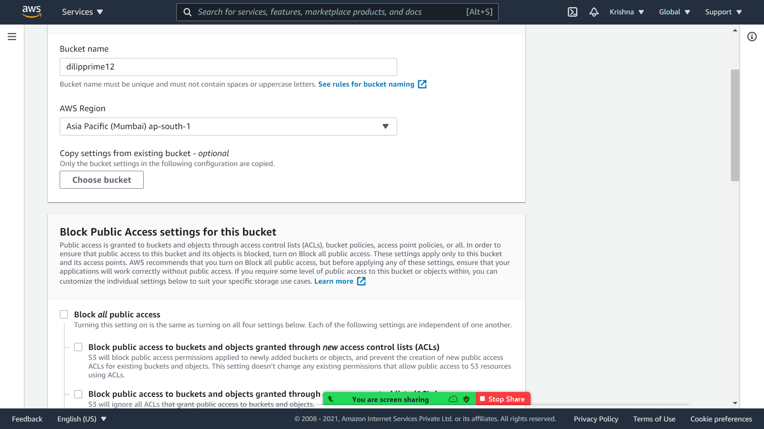

1. **Create Lambda**

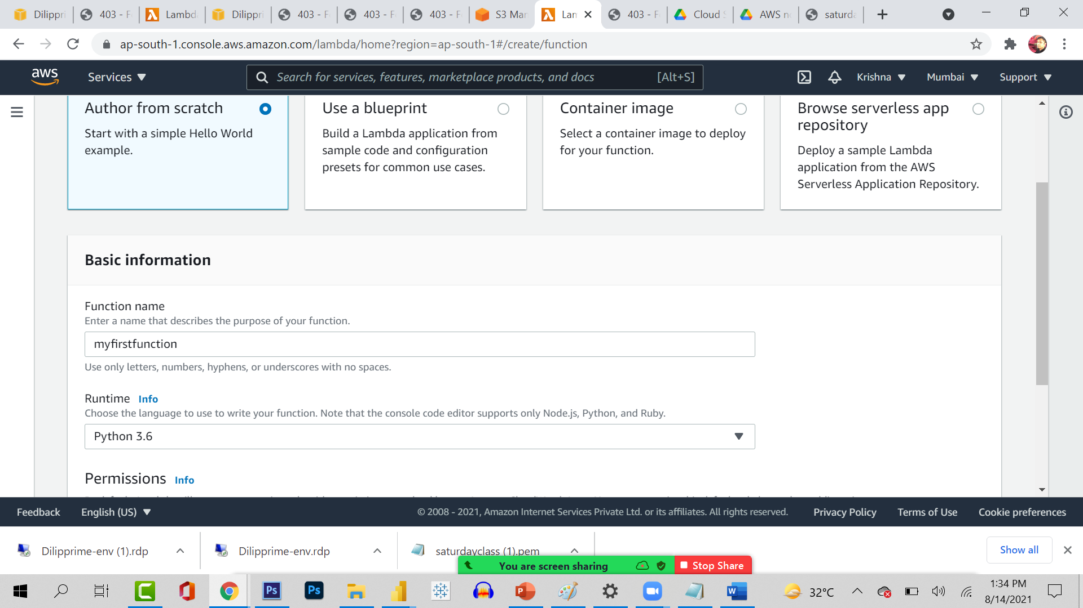

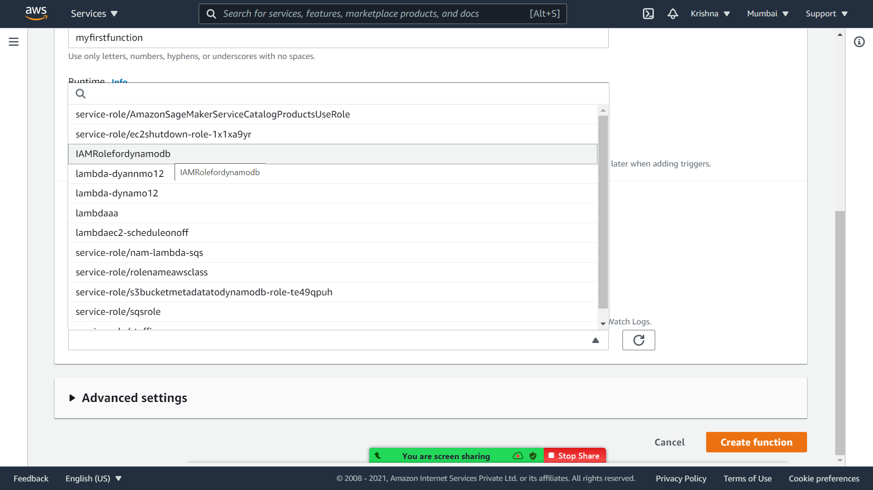

**Check configuration**

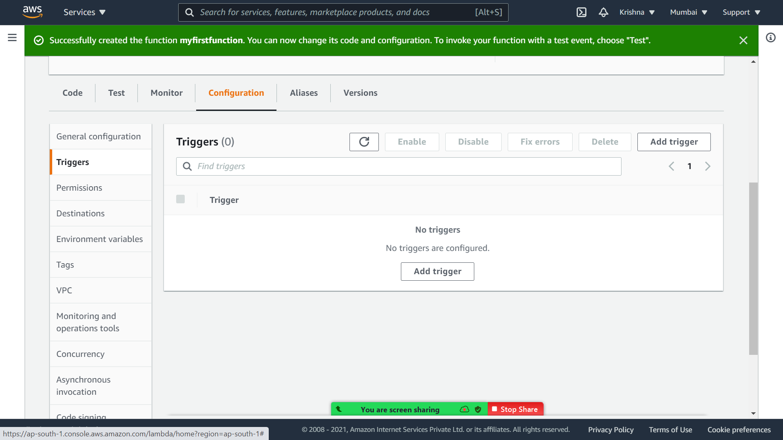

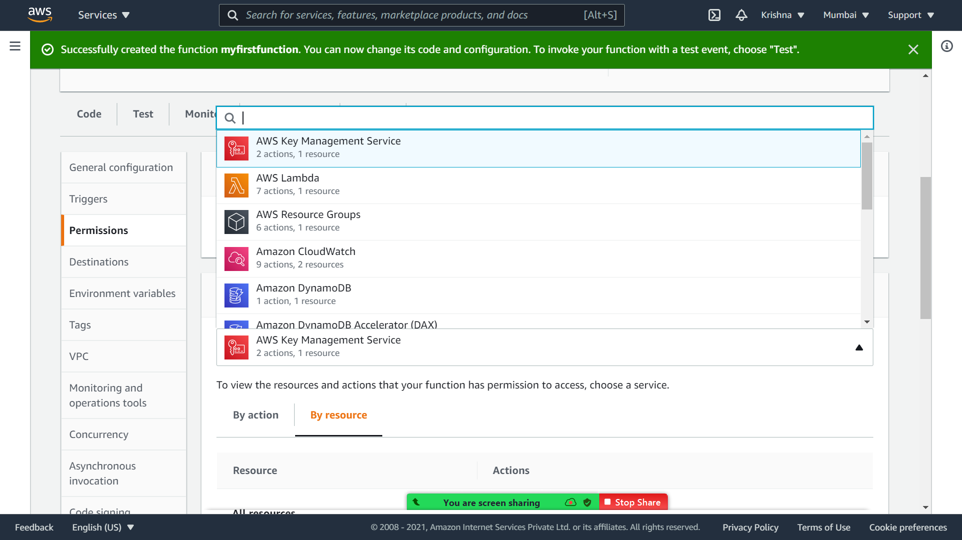



**Check timeout and max space from general config**

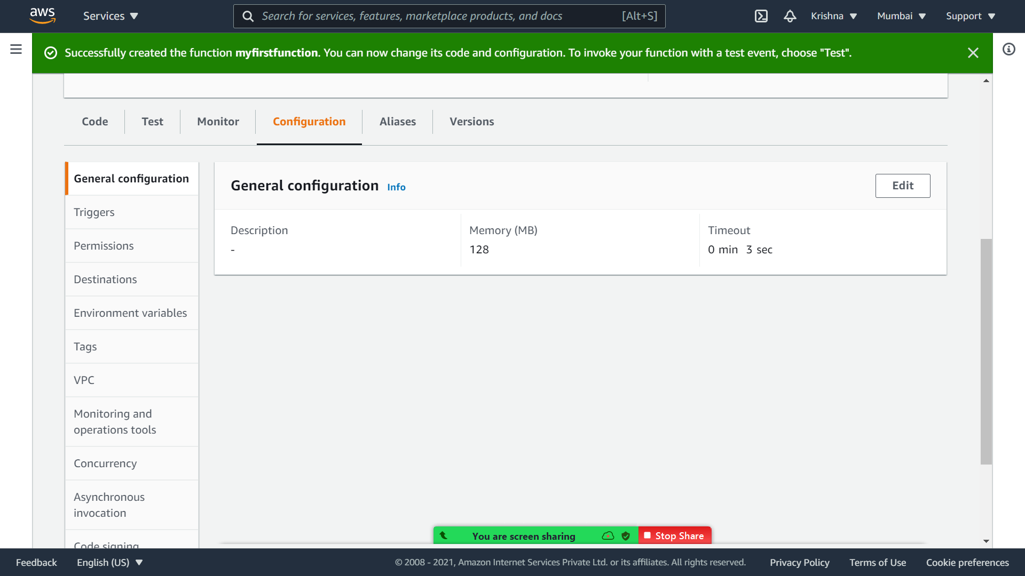

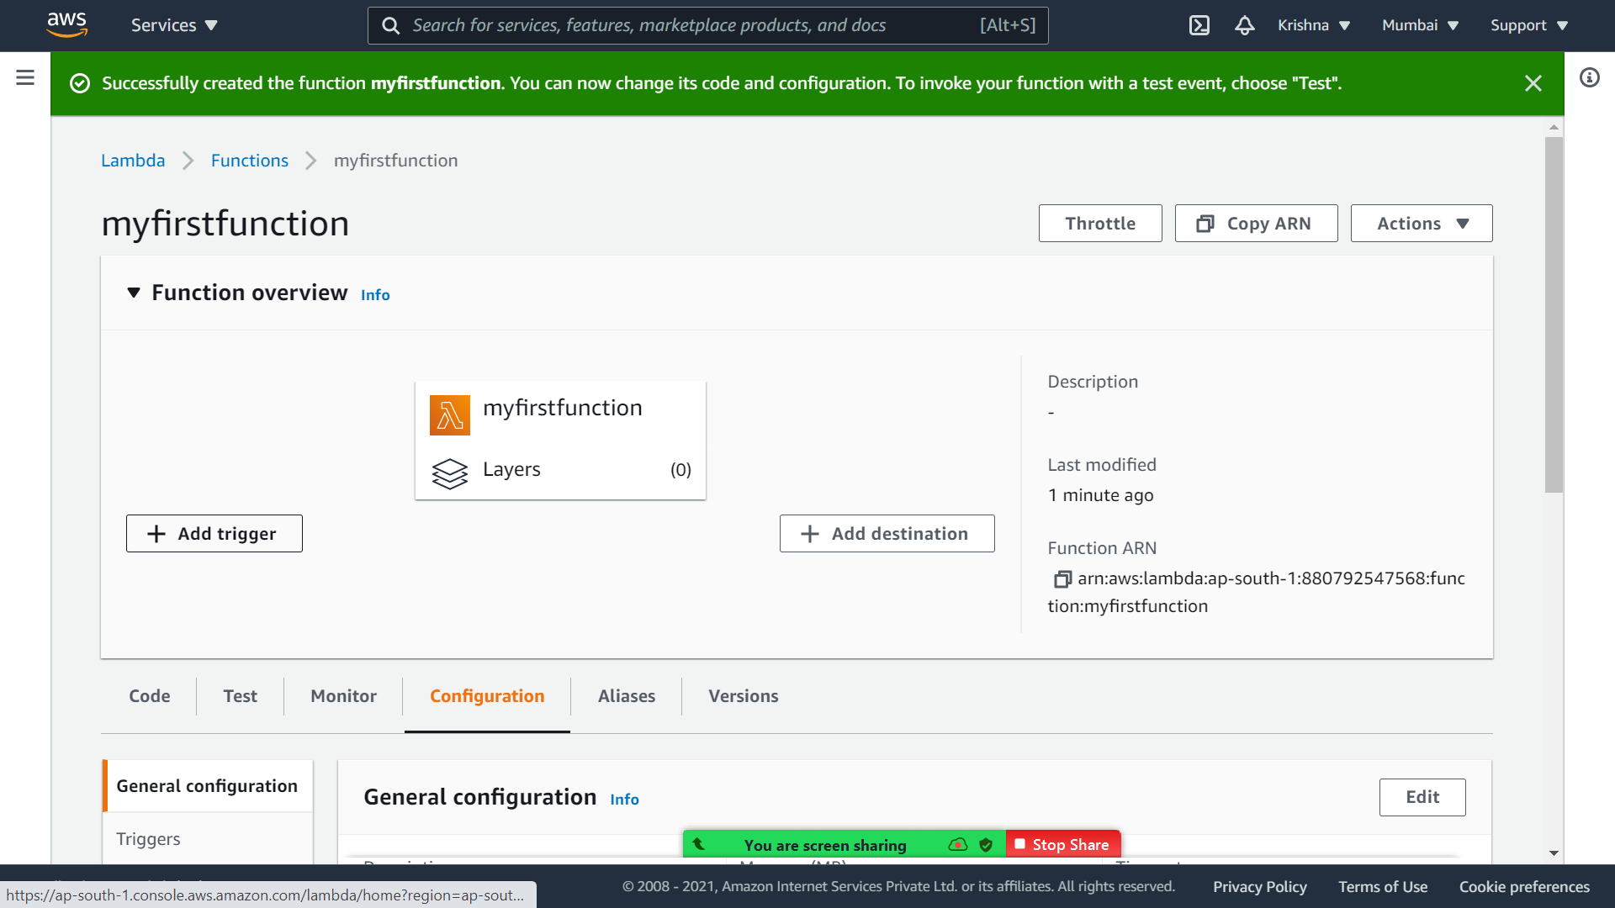



**After clicking on Add trigger**

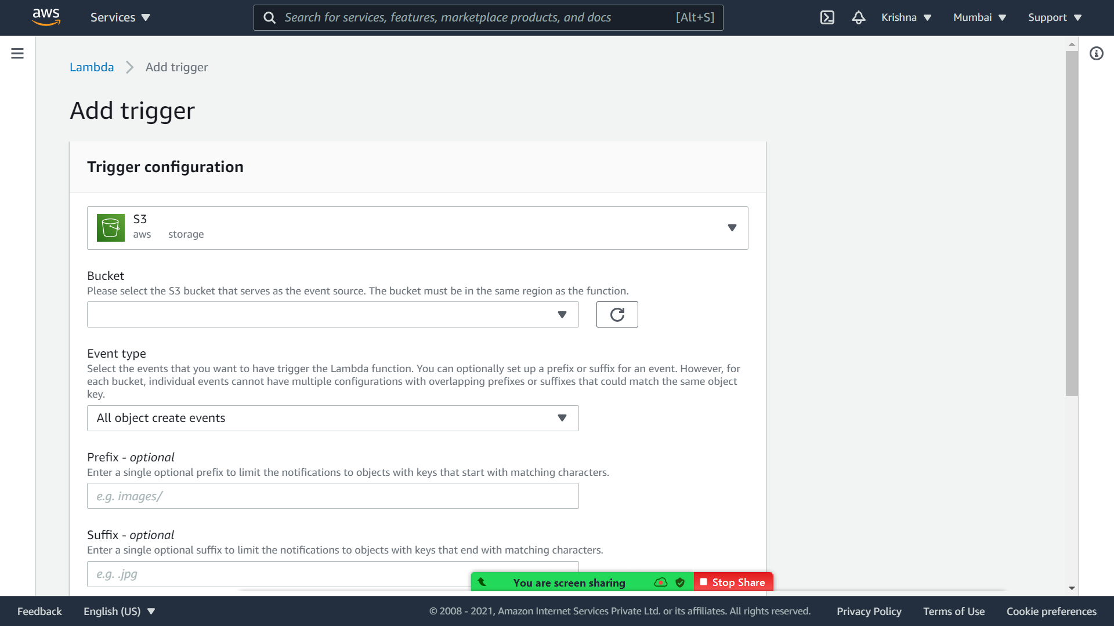

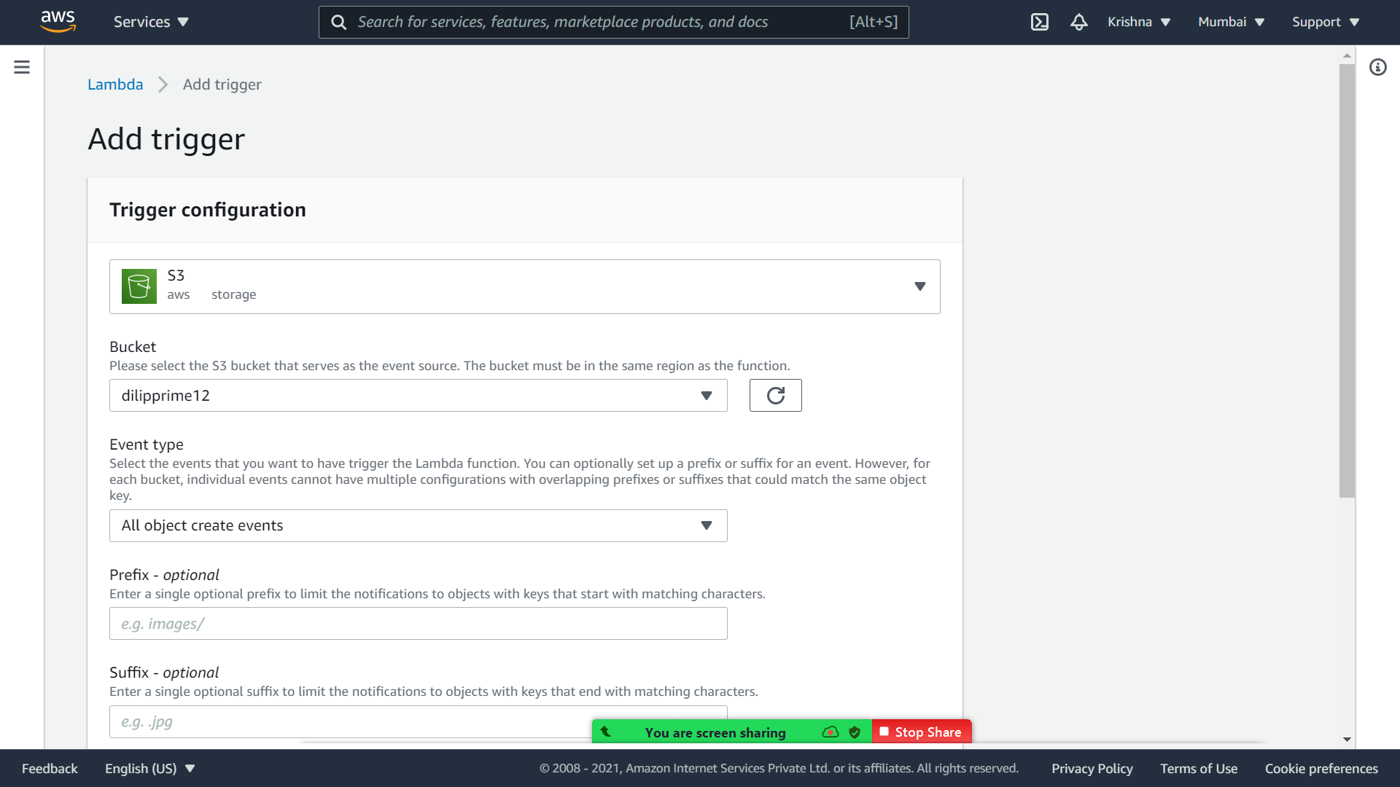



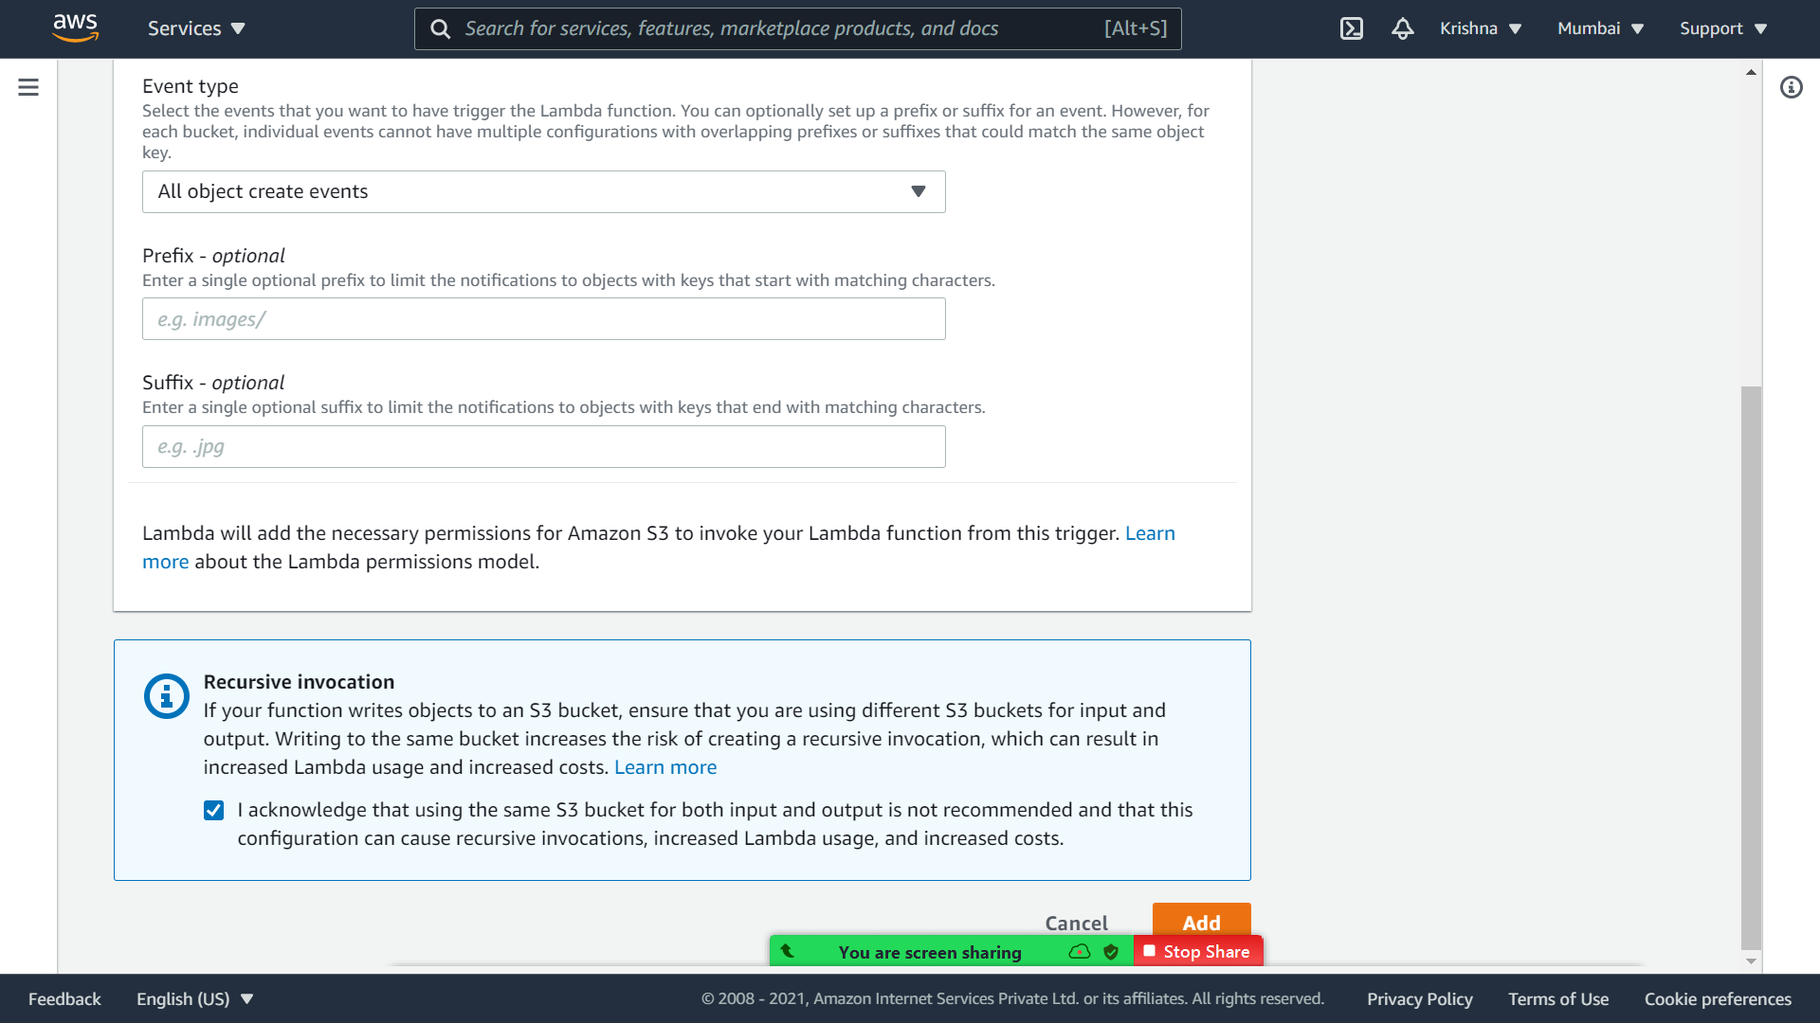

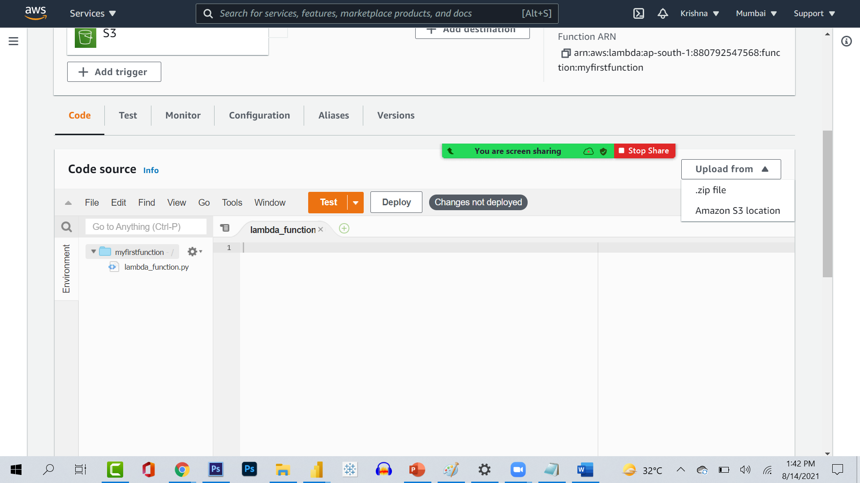

**import boto3**

**from uuid import uuid4**

**def lambda_handler(event, context):**

**s3 = boto3.client("s3")**

**dynamodb = boto3.resource('dynamodb')**

**for record in event['Records']:**

**bucket_name = record['s3']['bucket']['name']**

**object_key = record['s3']['object']['key']**

**size = record['s3']['object'].get('size', -1)**

**event_name = record ['eventName']**

**event_time = record['eventTime']**

**dynamoTable = dynamodb.Table('newtable')**

**dynamoTable.put_item(**

**Item={'unique': str(uuid4()), 'Bucket': bucket_name, 'Object': object_key,'Size': size, 'Event': event_name, 'EventTime': event_time})**

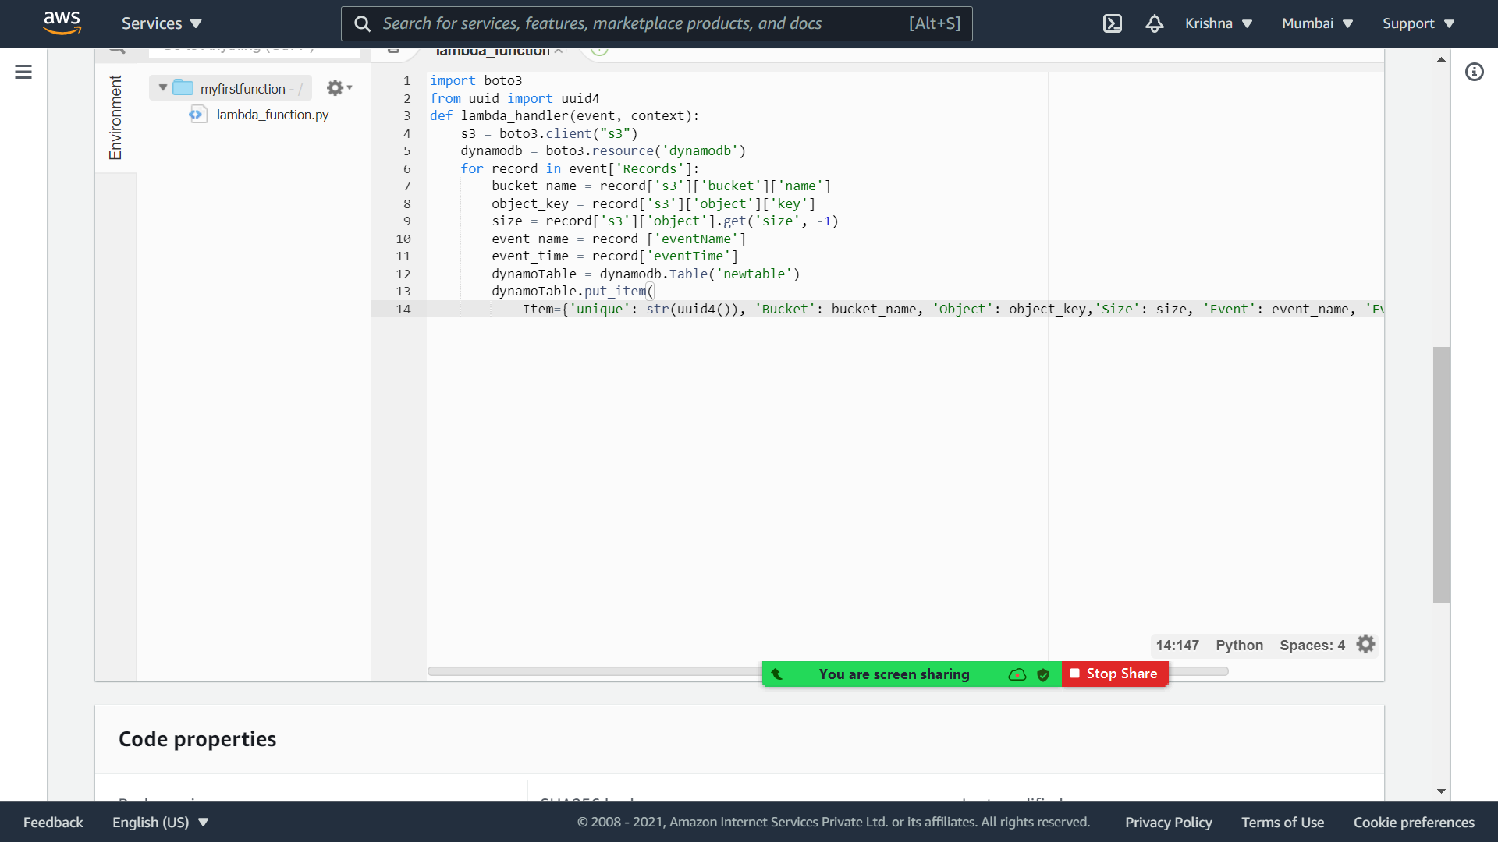



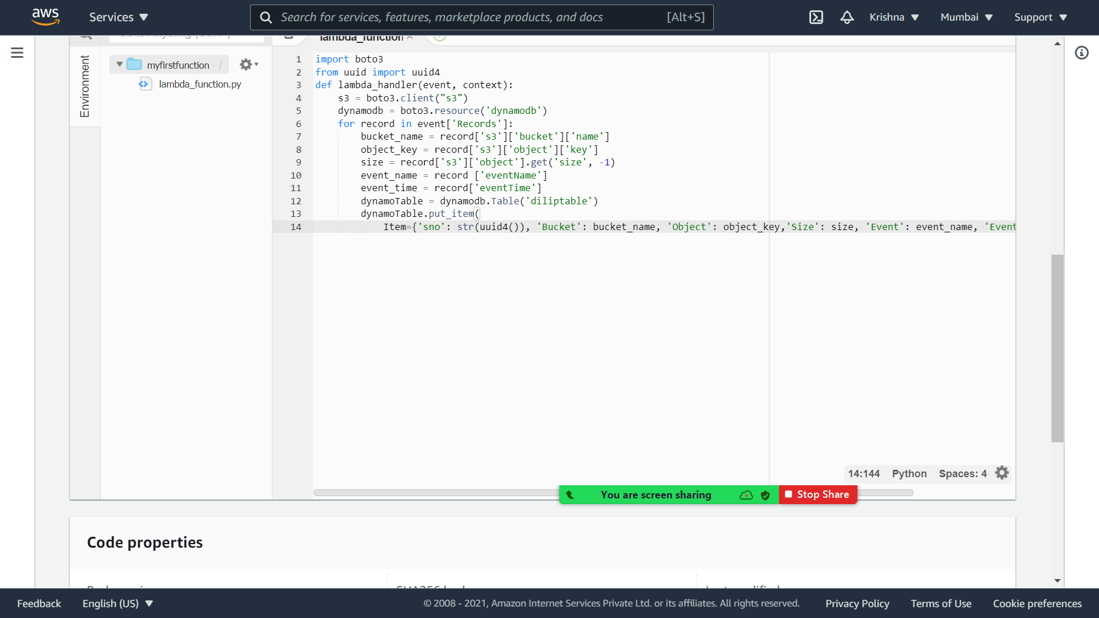



**Now go to dynamo db and create table with the name diliptable**

**And unique key as sno**

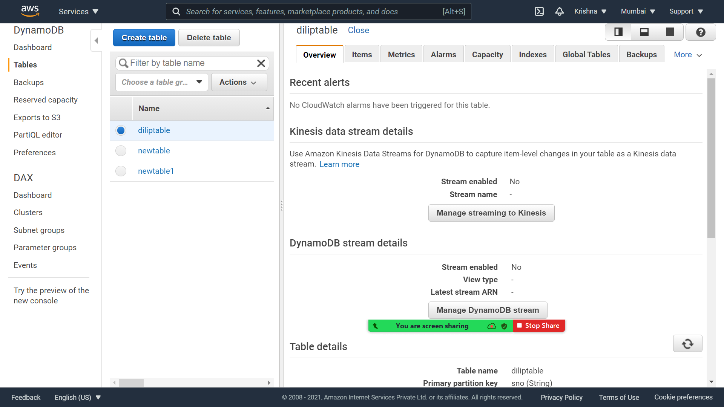

**Click on deploy in lambda (go to lambda and selection the function )**

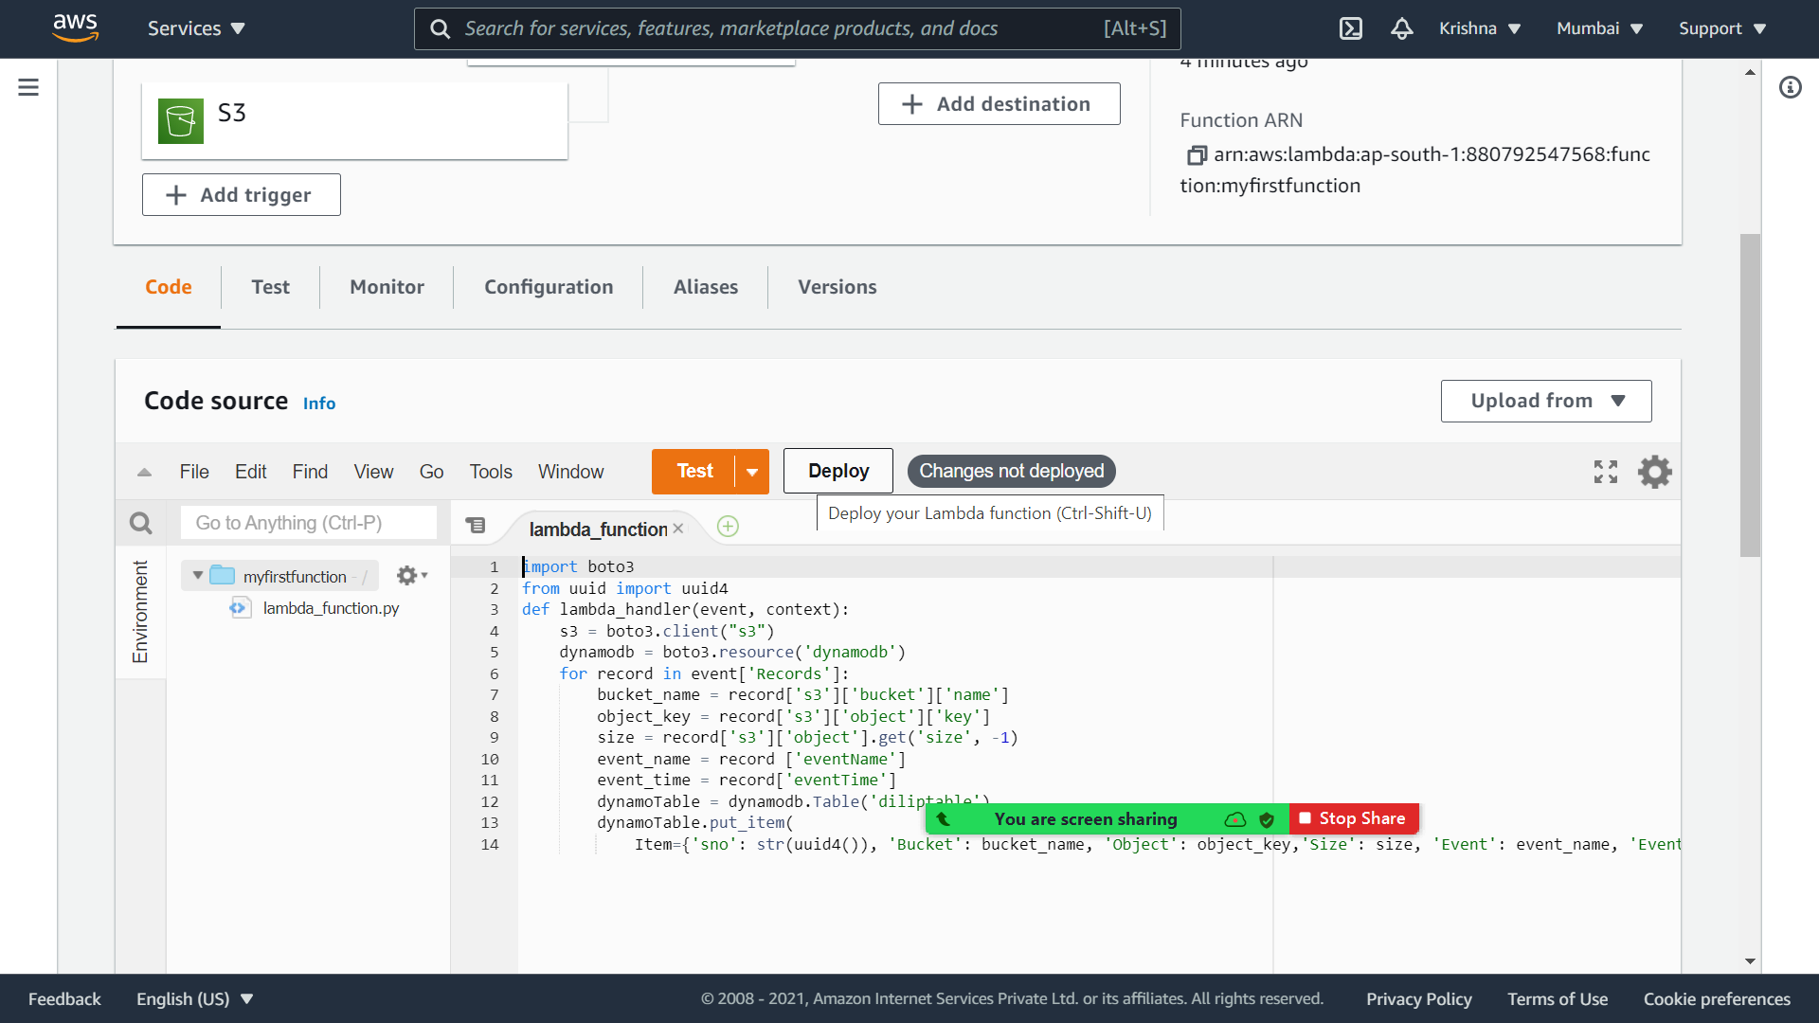



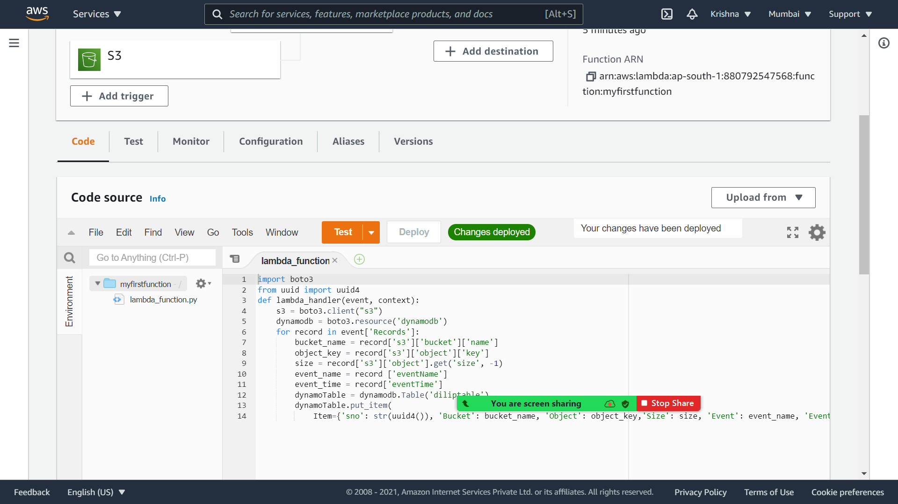



**Now go to s3 bucket and upload the content in s3 bucket**

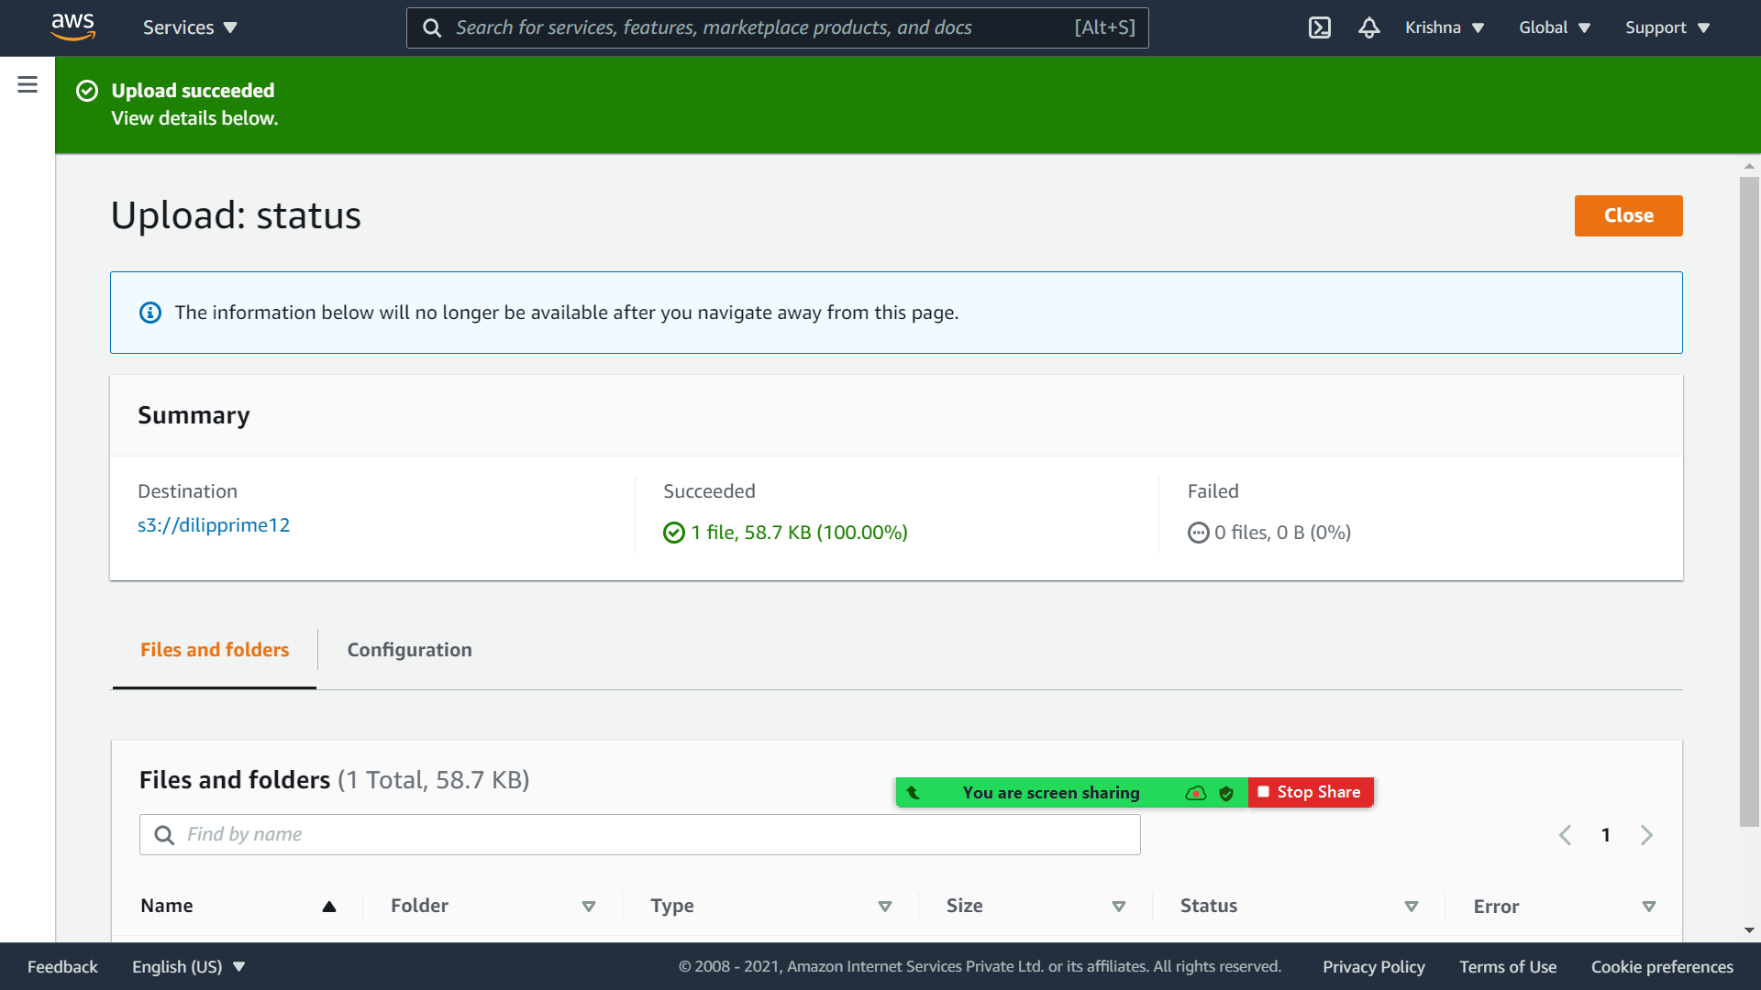

**Check the dilip table in dynamo db**

